Comparative Analysis of Machine Learning Models for QSAR Biodegradation Prediction

- Introduction
The objective of this report is to implement and compare multiple machine learning models for predicting biodegradability using the QSAR Biodegradation dataset. The project includes both custom implementation and library-based implementation of Logistic Regression, along with comparisons using different activation functions, Random Forest, and Support Vector Machines (SVM).

- Dataset Description
The QSAR Biodegradation dataset was obtained from the UCI Machine Learning Repository. The dataset contains molecular descriptors representing the structural and chemical properties of compounds.
Dataset Characteristics
- Number of samples: 1055
- Number of features: 41
- Target classes:
  - RB → Readily Biodegradable
  - NRB → Not Readily Biodegradable
The dataset is used as a binary classification problem where the model predicts whether a compound is biodegradable or not.

- Data Preprocessing
Before training the models, several preprocessing steps were performed:
- Data Cleaning
- Missing values were removed
- Duplicate rows were removed
- Train-Test Split
The dataset was divided into:
- 80% training data
- 20% testing data

- Feature Scaling
Standardization was applied to normalize feature values using mean and standard deviation.
The scaling formula used was:
X_scaled = (X - mean) / standard deviation
Feature scaling improves convergence during gradient descent and is especially important for Logistic Regression and SVM.

- Logistic Regression from Scratch
Logistic Regression was implemented manually using NumPy without using Scikit-learn.
Logistic Regression calculates a weighted combination of molecular descriptors and applies an activation function to estimate the probability that a compound is biodegradable. Based on this probability, the compound is classified as either readily biodegradable (RB) or non-readily biodegradable (NRB).
The model first computes the weighted sum of all the molecular descriptors
$$z=w_{1}x_{1}+ w_{2}x_{2} + ...+ w_{n}x_{n}+b$$
where:
- $x_{i}$= molecular descriptors
- $w_{i}$= learned weights
- $b$= bias term
The weighted sum is then passed through the chosen activation function which converts the output into a probability between 0 and 1.
If the probability is greater than 0.5, the compound is classified as biodegradable; otherwise, it is classified as non-biodegradable.
During training, the model minimizes prediction error using Binary Cross-Entropy Loss and updates weights through Gradient Descent. This process enables the model to learn which molecular descriptors have the greatest influence on biodegradability.
The different types of activation functions that can be used are:
- Sigmoid Activation Function
The sigmoid activation function converts linear outputs into probabilities between 0 and 1.
$$σ\left(z\right)=\frac{1}{1+e^{-z}}$$
- Cost Function
Binary Cross Entropy loss was used as the cost function:
$$J= \sum{[ y\log{(h)}+ (1-y)\log{(1-h) ]}}$$
- Gradient Descent
Gradient Descent is an optimization algorithm used to minimize the loss function of a machine learning model by iteratively adjusting its parameters. The algorithm calculates the gradient (partial derivative) of the loss function with respect to each model parameter and updates the parameters in the direction that reduces the prediction error.
$$θ=θ-α∇J\left(θ\right)$$
where:
- θ represents weights
- α is the learning rate
- ∇J(θ) is the gradient of the cost function

- Activation Function Comparison
Different activation functions were tested and compared:
The models were evaluated using:
- Accuracy
- Confusion Matrix
- Precision
- Recall
- F1-score
- ROC-AUC Curve

- Sigmoid
Used as the primary activation function for Logistic Regression.
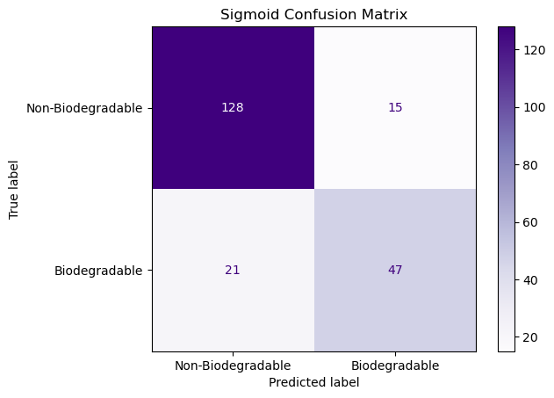
Classification Report:
precision recall f1-score support
0 0.89 0.92 0.90 143
1 0.82 0.75 0.78 68
accuracy 0.87 211
macro avg 0.85 0.84 0.84 211
weighted avg 0.87 0.87 0.87 211

- Tanh
Outputs values between -1 and 1
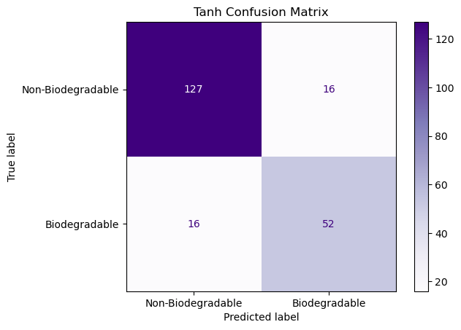
Classification Report:
precision recall f1-score support
0 0.89 0.89 0.89 143
1 0.76 0.76 0.76 68
accuracy 0.85 211
macro avg 0.83 0.83 0.83 211
weighted avg 0.85 0.85 0.85 211

- ReLU
Outputs zero for negative values and linear outputs for positive values.
The sigmoid activation function produced the best overall results because Logistic Regression is fundamentally designed around probabilistic sigmoid outputs.

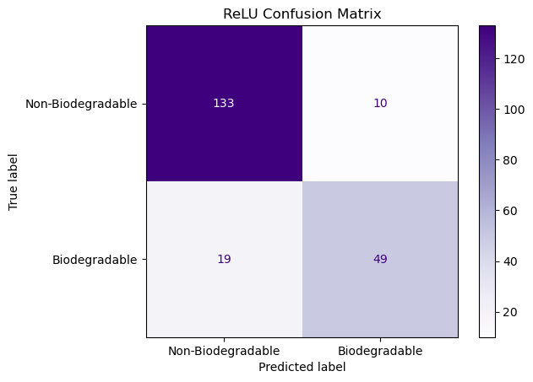
Classification Report:
precision recall f1-score support
0 0.88 0.93 0.90 143
1 0.83 0.72 0.77 68
accuracy 0.86 211
macro avg 0.85 0.83 0.84 211
weighted avg 0.86 0.86 0.86 211
- Logistic Regression using Scikit-learn.
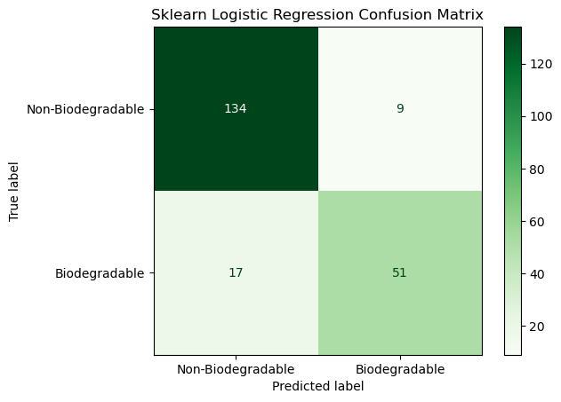
Classification Report:
precision recall f1-score support
0 0.89 0.94 0.91 143
1 0.85 0.75 0.80 68
accuracy 0.88 211
macro avg 0.87 0.84 0.85 211
weighted avg 0.88 0.88 0.87 211
Conclusions:
- Logistic Regression successfully classified biodegradable and non-biodegradable compounds using molecular descriptors.
- Sigmoid activation produced the best overall performance among the tested activation functions.
- The scikit-learn implementation slightly outperformed the manual implementation due to optimized training and regularization techniques.
- Logistic Regression provided a simple and effective baseline for biodegradability prediction.

- Random Forest
Random Forest is an ensemble learning algorithm that combines multiple Decision Trees to improve classification performance and reduce overfitting.
Instead of training a single tree, Random Forest generates many trees using randomly selected subsets of training samples and features. Each tree independently learns decision rules based on molecular descriptors.
For example, one tree may learn rules using molecular weight and hydrophobicity, while another tree may focus on structural descriptors. This diversity helps the model capture different patterns within the QSAR dataset.
During prediction:
- Each tree classifies a compound as RB or NRB.
- All trees cast a vote.
- The final class is determined by majority voting.
Advantages:
- Handles non-linear relationships
- Less sensitive to feature scaling
- Reduces overfitting through ensemble learning
Random forest algorithm was implemented manually with the following outcomes:
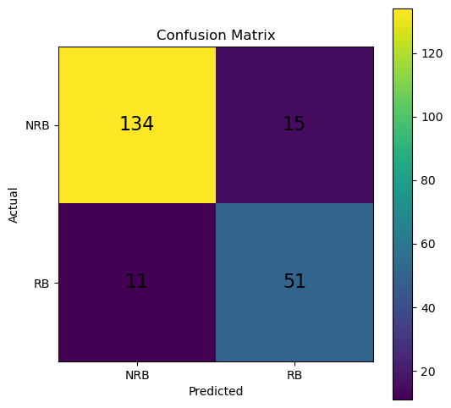
Classification Report:
precision recall f1-score support
NRB 0.92 0.91 0.91 143
RB 0.78 0.81 0.80 68
accuracy 0.87 211
macro avg 0.85 0.86 0.85 211
weighted avg 0.89 0.88 0.87 211
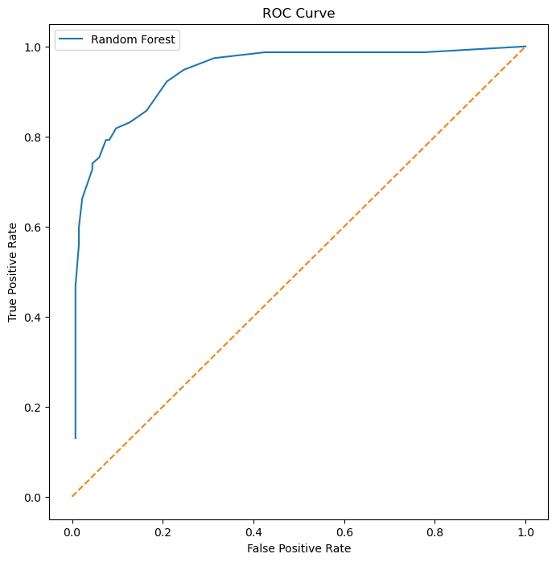
- Random Forest using Scikit-learn.
Random Forest was implemented using the Scikit-learn library to classify compounds as Readily Biodegradable (RB) or Not Readily Biodegradable (NRB).
The Scikit-learn implementation provides optimized tree construction, efficient feature selection, and built-in ensemble techniques, resulting in improved performance and computational efficiency.
Classification Report:
precision recall f1-score support
NRB 0.93 0.91 0.92 143
RB 0.79 0.84 0.82 68
accuracy 0.89 211
macro avg 0.86 0.87 0.87 211
weighted avg 0.89 0.89 0.89 211
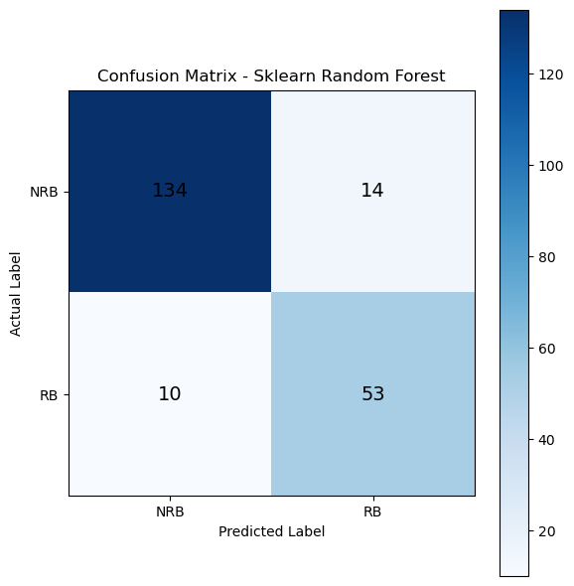
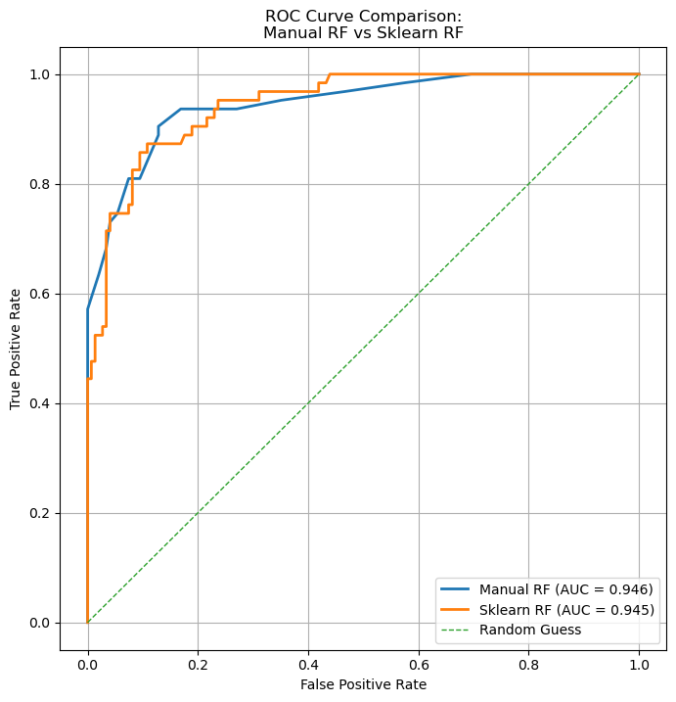
Conclusions:
- Random Forest achieved strong classification performance by combining predictions from multiple decision trees.
- The ensemble approach reduced overfitting and improved prediction stability.
- The manually implemented Random Forest produced results comparable to the sklearn implementation.
- Random Forest demonstrated excellent capability for modeling complex relationships within the QSAR dataset.

- Support Vector Machine (SVM)
Support Vector Machine (SVM) is a supervised machine learning algorithm used for classification tasks. The objective of SVM is to find the optimal decision boundary, known as a hyperplane, that maximizes the margin between different classes.
For the QSAR biodegradation dataset, SVM uses molecular descriptors to separate biodegradable and non-biodegradable compounds. The model focuses on data points closest to the decision boundary, called support vectors, which have the greatest influence on classification.
Working Principle:
- Molecular descriptors are represented as points in a multidimensional space.
- SVM identifies the optimal hyperplane that best separates RB and NRB compounds.
- Support vectors define the position of the decision boundary.
- New compounds are classified based on which side of the hyperplane they fall.
Advantages:
- Effective in high-dimensional feature spaces
- Works well with complex datasets
- Maximizes class separation
- Robust against overfitting
SVM was first implemented manually with the following outcomes:
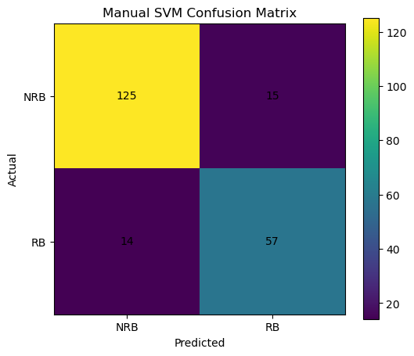
Classification Report:
precision recall f1-score support
-1 0.90 0.89 0.90 140
1 0.79 0.80 0.80 71
accuracy 0.86 211
macro avg 0.85 0.85 0.85 211
weighted avg 0.86 0.86 0.86 211

- SVM using Scikit-learn
SVM was implemented using scikit-learn and the following outcomes were observed.

Classification Report:
precision recall f1-score support
-1 0.89 0.89 0.89 140
1 0.79 0.79 0.79 71
accuracy 0.86 211
macro avg 0.84 0.84 0.84 211
weighted avg 0.86 0.86 0.86 211

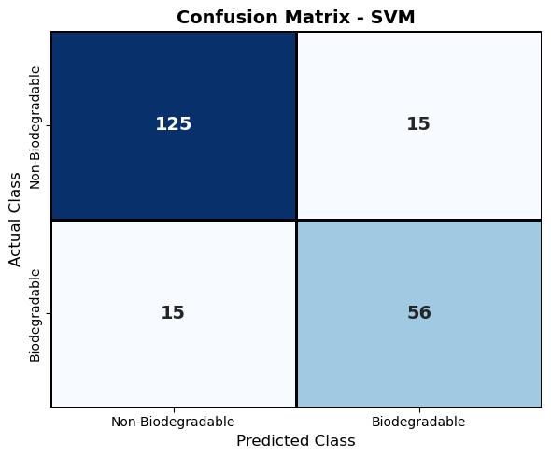
Conclusions:
- SVM effectively classified biodegradable and non-biodegradable compounds using molecular descriptors.
- The maximum-margin principle improved class separation and generalization performance.
- Support vectors played a crucial role in defining the optimal decision boundary.
- SVM proved to be a reliable classification technique for QSAR biodegradability prediction.

- Evaluation Metrics
Several evaluation metrics were used to assess model performance.
- Accuracy
Measures overall prediction correctness.
- Precision
Measures how many predicted positives were actually positive.
- Recall
Measures how many actual positives were correctly identified.
- F1-Score
Harmonic mean of precision and recall.
- Confusion Matrix
Shows:
- True Positives
- True Negatives
- False Positives
- False Negatives
- ROC Curve
ROC curves were plotted to compare classification performance across different thresholds.

- XGBOOST Algorithm
XGBoost (Extreme Gradient Boosting) is an advanced ensemble machine learning algorithm based on gradient boosting. It builds multiple decision trees sequentially, where each new tree attempts to correct the errors made by the previous trees. Unlike Random Forest, which trains trees independently, XGBoost trains trees one after another, gradually improving the model's predictive performance.
During training, the first decision tree generates initial predictions. The errors (residuals) from these predictions are then used to train the next tree. This process continues iteratively, with each tree focusing on the mistakes of the previous trees. The final prediction is obtained by combining the outputs of all trees.
Advantages:
- Captures complex non-linear relationships between features.
- Handles high-dimensional datasets effectively.
- Includes regularization to reduce overfitting.
- Provides high predictive accuracy.
- Supports feature importance analysis.
Working Principle:
- Train an initial decision tree on the dataset.
- Calculate prediction errors (residuals).
- Train a new tree to correct those errors.
- Repeat the process for multiple boosting rounds.
- Combine the predictions from all trees to produce the final output.
XGBoost was performed using Scikit-learn with the following results
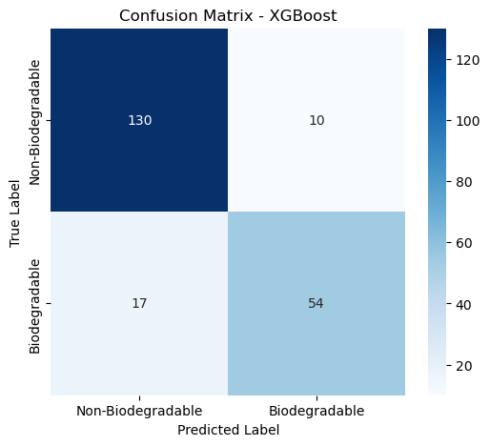
Classification Report
precision recall f1-score support
Non-Biodegradable 0.8844 0.9286 0.9059 140
Biodegradable 0.8438 0.7606 0.8000 71
accuracy 0.8720 211
macro avg 0.8641 0.8446 0.8530 211
weighted avg 0.8707 0.8720 0.8703 211
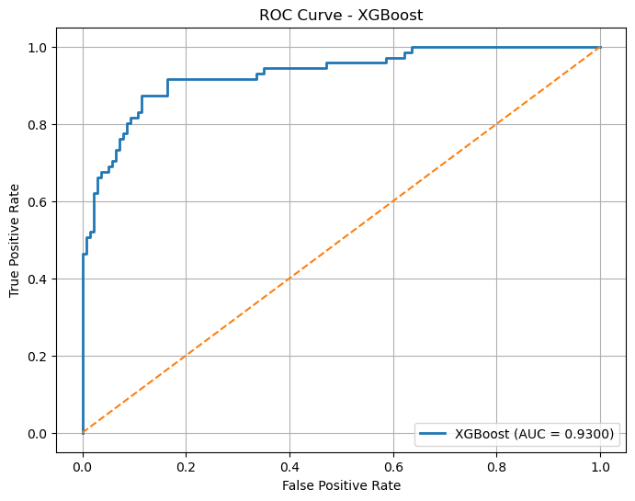
Conclusion:
  - XGBoost successfully modeled the relationship between molecular descriptors and biodegradability classes.
  - The boosting approach progressively reduced prediction errors and improved classification performance.
  - Regularization techniques helped prevent overfitting while maintaining high accuracy.
  - XGBoost demonstrated excellent capability for predicting biodegradability and is considered one of the most powerful ensemble learning algorithms for classification tasks.

- Multi-Layer Perceptron (MLP)
The Multi-Layer Perceptron (MLP) is a feedforward artificial neural network consisting of an input layer, one or more hidden layers, and an output layer. The model learns complex non-linear relationships between molecular descriptors and biodegradability through interconnected neurons.
Each neuron computes a weighted sum of its inputs and applies an activation function to produce an output. During training, predictions are generated through forward propagation, while the network learns by adjusting weights using backpropagation and gradient descent to minimize classification error.
Advantages:
- Captures complex non-linear relationships
- Learns feature interactions automatically
- Effective for high-dimensional datasets
- Can model complex decision boundaries
Working Principle
- Molecular descriptors are fed into the input layer.
- Information passes through hidden layers using weighted connections.
- Activation functions introduce non-linearity.
- The output neuron predicts whether a compound is RB or NRB.
- Backpropagation calculates errors and updates weights to improve predictions.
MLP Algorithm was executed using Scikit-learn with the following outputs:
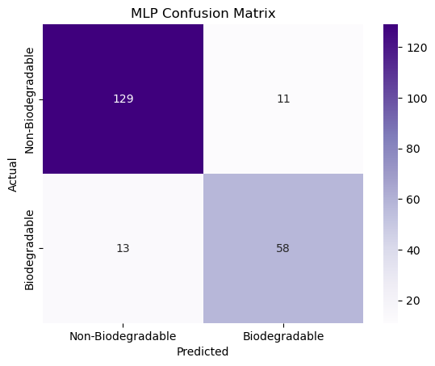
Classification Report:
precision recall f1-score support
0 0.91 0.92 0.91 140
1 0.84 0.82 0.83 71
accuracy 0.89 211
macro avg 0.87 0.87 0.87 211
weighted avg 0.89 0.89 0.89 211
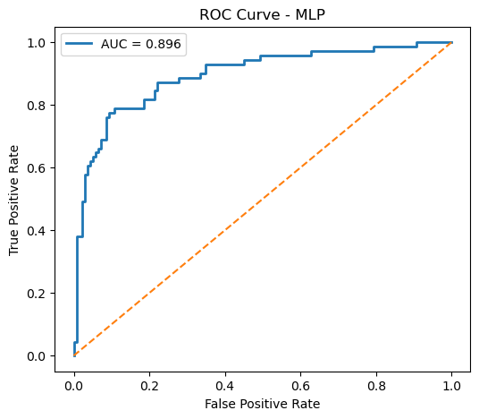
The different types of solvers used in Scikit-Learn's MLPClassifier are:
  - ADAM (Adaptive Moment Estimation)
    - Combines Gradient Descent and Momentum
    - Adjusts learning rates automatically for different weights.
    - Uses past gradients to speed up convergence
Adam is an adaptive optimization algorithm that updates network weights using estimates of first and second moments of gradients, resulting in faster and more stable convergence.

  - SGD (Stochastic Gradient Descent)
    - Instead of using the entire dataset to update weights, SGD updates weights using one sample or a small batch at a time.
Stochastic Gradient Descent updates model weights iteratively using small subsets of training data, reducing computational cost and enabling efficient learning.

  - LBFGS (Limited-memory Broyden-Fletcher-Goldfarb-Shanno)
    - Uses second-order optimization techniques.
    - Approximates the Hessian matrix (curvature information).
    - Finds optimal weights more precisely.
LBFGS is a quasi-Newton optimization algorithm that approximates second-order derivatives to achieve faster convergence and accurate parameter estimation.
All three were implemented and then compared with each other

Solver Accuracy ROC-AUC
adam 0.857820 0.895775
sgd 0.886256 0.918612
lbfgs 0.843602 0.880785
